SciX 2021 – Teams Channels

**GENERAL CHANNEL**

* **Welcome to SciX 2021**

Hi everyone,

Welcome to the cognitive science project. Congratulations on being accepted into this SciX program!

In this project you will have the opportunity to carry out a psychology experiment from start to finish. This project will push you to think critically, to come up with your own hypotheses for classic psychology experiments (e.g. [Cognitive Reflection Test](https://mindyourdecisions.com/blog/2013/06/24/can-you-correctly-answer-the-cognitive-reflection-test-83-percent-of-people-miss-at-least-1-question/) and [Flanker Task](https://uilots-labs.wp.hum.uu.nl/wp-content/uploads/sites/99/2014/11/flanker-task-example.png), etc), and to learn about on online platform called MTurk that can be used for data collection. You will also have the opportunity to go through several tutorials to learn about a programming language called R that we will use during data analysis. No prior knowledge of programming or R is necessary!

Before the summer school, there are some skills we would like you to develop, and some background information to learn. This content is delivered via posts and files in the prework channels (indicated by "P1" etc). We strongly encourage you to answer question prompts, ask questions, share good resources you find on a topic and generally get immersed in the science and with your peer research group!

We look forward to meeting all of you. Please post any questions about the program or content in the QnA channel.

- Jenny and Steve

* **Instructor Introductions**

**Jenny Sloane - PhD Mentor**

[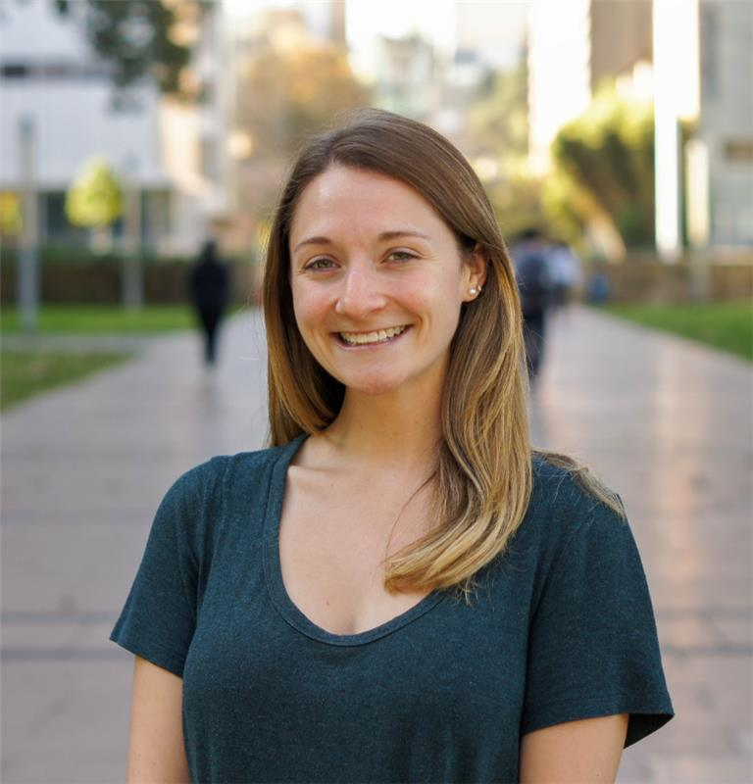](https://au-prod.asyncgw.teams.microsoft.com/v1/objects/0-eau-d2-2409a1b6d1b6c65e35d0dd8a7977bbcf/views/imgo)

*Jenny is a PhD student studying cognitive psychology at UNSW. She received her BA in psychology from the University of Maryland and her Masters of Science in experimental psychology from Syracuse University. Jenny's research interests include studying the effects of interruptions and time-pressure on decision-making. She has several years of experience as a teaching assistant for a range of psychology courses. Jenny was a member of the UNSW Women in Maths and Science Champions Program, where she has and continues to participate in outreach activities to encourage and inspire women to pursue careers in math and science.*

*You can learn more about Jenny from this* [*blog post!*](https://blogs.unsw.edu.au/mathssciencechampions/blog/2019/05/the-life-of-a-mathematical-psychologist-jenny-sloane/)

**Tehilla Mechera-Ostrovsky - PhD Mentor**

*Tehilla is a PhD student studying cognitive psychology at UNSW in Prof. Ben Newell’s Lab. She received her Bachelor of Science and Master of Science from the University of Basel, Switzerland. Her M.Sc. thesis was about the role of memory and its biases in value-based decisions. Her current research focuses on examining the effect of information seeking in risky decision-making and on learning how random choice behaviour impacts findings in risk elicitation tasks.*

**Steve Most - Academic Lead**

[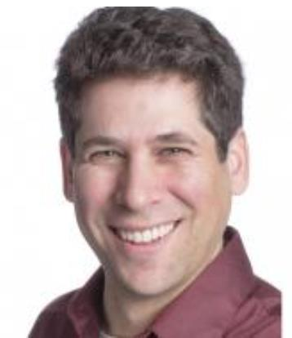](https://au-prod.asyncgw.teams.microsoft.com/v1/objects/0-eau-d4-5b99d8c45697b31f4f5dbfb9b4aca88e/views/imgo)

*Steve’s research is grounded in cognitive psychology, with strong links to social psychology, clinical psychology, and neuroscience. He specialises in relationships between motivation, emotion, and attentional control. Topics include mechanisms of emotion-driven attentional bias, how attention and emotion shape our awareness of the world, impacts of physical and emotional stress on cognition, and emotion regulation. He also specialises in understanding the implications of these processes for real-world safety, including on the roadways. Steve is also passionate about fostering understanding of psychology outside the university.*

* **Introduce yourself!**

Post an introduction for your peers (and your mentors) here! What school you're from, why you chose this project - it's good to know a little bit about each other before we meet in January.

* **Experience with Programming?**

Are you completely new to coding? Are you completely new to coding in R? Do you already have experience coding, if so what language(s)?

We do not assume that you have ever used R (or any other programming language) before. In our project, we will teach you the basics for you to carry out your own data analyses. To make sure we're not going too fast (or too slow!), please comment as a reply to this thread and let us know what experience you have with R or any other programming languages.

* **Suggested Timeline**
* P1. Cognitive Science - complete by early December (Learning R will take more time to get through so please make sure to leave plenty of time for P2.)
* Initial hypothesis - Due January 4th
* P2. Learning R - complete by early/mid January (this will leave time for any questions and to focus on refining your hypotheses)
* **Important Announcements**

We are very excited that SciX summer school is just over 2 weeks away! We are looking forward to teaching and working with all of you. With the summer school quickly approaching, it is really important that you spend time completing your pre-work over the next couple of weeks.

* Please remember, **your hypotheses are due TOMORROW.** Make sure to post your hypothesis in the excel file in the P1 Cognitive Science channel if you haven't already. The hypotheses are looking good! We've noticed no one (so far) has posted hypotheses on either the Flanker or Random Dot Motion tasks, so Tehilla will be posting a couple of short videos on these tasks as a reminder of what the tasks are as we want to encourage you to include these tasks in your hypotheses.
* We will post the experiment this coming Tuesday in the SciX General group for all SciX members, friends, and family to fill out!! Ideally, everyone should have a hypothesis before we post the experiment.
* Once you have a hypothesis, you should begin working on the Learning R pre-summer school work. Please don't save this for the last minute as learning a programming language will take a fair bit of time.
* **Tehilla and I will hold a video QnA session on Thursday (7th) from 3-4pm**. If you have any questions (specifically about R, but general questions are also welcome), this is a great opportunity to ask. All you have to do is go to the QnA channel and join the meeting at 3pm on Thursday.
* **Summer School Schedule**

General Don't worry - this isn't more work! I thought you'd be interested in having a closer look at our schedule for next week. Please keep in mind this is a flexible schedule, so things may change or get rescheduled as we go. Also please note this is only a schedule for your time with us (the PhD mentors), the summer school is from 9:00-4:30 every day.

* **Mentor Feedback/Survey Link**

Hi General - here's the link to the survey to give us (Tehilla and me) feedback on our teaching and the course in general. It shouldn't take more than 10 minutes to complete. We'd really appreciate it if you're able to take the time to fill this out! Thanks 🙂

**P1. COGNITIVE SCIENCE CHANNEL**

**Note: excel doc for posting hypotheses was really useful

* **Intro to cognitive psychology**

To get more familiar with the field, please read this chapter. Don't worry too much about the fine details, this is just to give you a little bit of background to the world of cognitive psychology.

* **Test our experiment!**

Before moving on to anything else, follow the link below to test out our experiment! You will complete 3 different cognitive tasks, which are "classic" studies that are commonly used in cognitive psychology, and 3 surveys/questionnaires. Completing the experiment should take approximately 30 minutes.

Pay attention to which tasks and/or questions you think are particularly interesting, as this experiment is what you will be creating your hypotheses from. You may even want to begin thinking and generating possible hypotheses. The next post will have more information with regards to generating hypotheses.

* **Hypothesis (Due January 4th)**

As part of your Extension Science project you are going to need to develop your own hypothesis. Although this may seem daunting at first, your mentor has provided a few example hypotheses to show what can be tested within the scope of this project.

You've just gone through and completed the full experiment that we will be analysing during the summer school. Now, it is your turn to think of a hypothesis you are interested in testing!

Your hypothesis needs to relate to the current experiment. As a reminder, the experiment includes:

* Cognitive Reflection Test
* Flanker Task
* Random Dot Task
* Demographic questions (age, gender, education)
* Impulsivity Scale
* Self-Control Scale
* Big 5 Personality Inventory

*Sample hypotheses:*

1. Are higher scores on the impulsiveness scale associated with more errors on the Flanker Task?
2. Is performance on the Flanker task correlated with performance on the Random Dot Motion Task?
3. Is performance on the Cognitive Reflection Test associated with any of the Big 5 personality traits?

Take time and think about a hypothesis that you find interesting and would want to explore further.

Please reply to this post with an **initial hypothesis no later than January 4th**, but feel free to post earlier and we will be able to help refine your hypotheses and answer any questions.

* **Experiment Update**

Hi P1. Cognitive Science - we've just posted our experiment in the SciX General channel! This means we've officially started data collection 😁

In order to make sure we get plenty of responses, **we'd like each of you to try to get at least 2 people to complete our experiment.** All you have to do is send this link <http://scix-experiment.psy.unsw.edu.au/> to your family and/or friends. It will take about 30 minutes to complete.

This also means it's really important to **post your hypotheses ASAP** (if you haven't already).

**P2. LEARNING R CHANNEL**

**Note: Rstudio Cloud was a HUGE help and using an excel doc to track students’ progress

* **Downloading and Installing R**

In our project, we will be working with a programming language called R. We don't expect you to have any prior knowledge in programming, so please don't worry if this is the first time you've ever even heard of R!  
  
R is a free programming language that is often used for analyzing data and creating high quality visualizations. Before doing anything else, you we will need to download and install R and "RStudio" on your computer/laptop.

Follow these instructions to get R and Rstudio on your computers and learn about RStudio. These instructions are part of a book, but for now you should just focus on this one page on "How to download and install R".

Please like this post when you have successfully downloaded R and RStudio on your computer and please comment here if you have any problems or questions with the installation process.

<https://rstudio-education.github.io/hopr/starting.html>

* **RYouWithMe**

Please note: when going through the CleanItUp tutorials on RYouWithMe, please skip the entire CleanItUp 4 section, so go straight from CleanItUp 3 to CleanItUp 5.

As part of your summer pre work, you will go through a series of video tutorials called "RYouWithMe?" created by Jenny Richmond who is a psychology professor at UNSW. The link is posted below.

Please have a read through the About section to learn more about this series of tutorials. On the left hand side of the website, you will see 4 more sections: BasicBasics, CleanItUp, VizWhiz, and MarkyMark. Your job pre-summer school, is to work your way through the first two sections, BasicBasics and CleanItUp (we will most likely work through at least some of VizWhiz during the summer school). As you watch the videos, you should try to code along - the best way to learn how to code is to code! I promise you will make lots of mistakes, but that is all part of the process and we will be here to help you along the way. 🙂

We will also post a few questions for each section just as a way to check in with everyone - keep an eye out for these questions, they will be posted within the next week.

<https://rladiessydney.org/courses/ryouwithme/>

* **RYouWithMe Assignment**

Hi everyone,

Below you will find a link to RStudio Cloud, which is a platform that will allow us to share data/assignments and teach R online. RStudio Cloud will look exactly like the RStudio you've already downloaded, but for now you will only be working online through RStudio Cloud. We will post all the files and everything you will need for programming on RStudio Cloud. With RStudio Cloud, Tehilla and I will be able to see the changes you've made to the assignments, but other students won't be able to see your work. This way, if you get stuck or have questions, you can ask on Teams but we will be able to look at your code and help you!

Please sign up for the "Cloud Free" plan (you will be given the option to login via your google or github account or create your own account) and "join the space". Once you join the space, you will have access to the "SciX - summer school" project. Then, follow the instructions below.

[RYouWithMe_Assignments](https://rstudio.cloud/spaces/105918/join?access_code=ua1lsXBLJ4oW6IWf0UzRbM%2F7sdMTthmMZU%2BHeVdm)

* First, read the About section (I think you should automatically be taken to this page)
* Click the Projects tab and you should see 2 assignments: BasicBasics and CleanItUp
* You should complete these assignments while you watch the RYouWithMe tutorials or shortly after as the material is related. Feel free to go back and re-watch parts of the videos if you need
* Once you start an assignment, make sure to save your work as you go (ctrl+s or command+s or the save icon), but you can close the program and come back to it later
* *Please like this post when you have successfully logged in and started the first project!*

Please post any questions about RStudio Cloud or the assignment here.

**SUMMER SCHOOL MATERIAL CHANNEL**

* Created right before the start of the summer school
* Posted schedule here
* Held all lectures here
* Folders for
  + Monday (Intro + Pre Reg)
  + Tuesday (Cognitive Tasks + Stats Intro)
  + Wednesday + Thursday (Data Analysis)
* Folders had recorded lectures, lecture slides, papers, scripts, etc

**MINI GROUP CHANNELS**

* 6 mini groups (~ 3 students in each)
* Tehilla had 3 and I had 3
* Tell students to “hide” other mini group channels, but not to delete them!